**Opening a wine bar around Manhattan**

Fabio Isa

14 April 2020

**1. Introduction**

**1.1 Background**

In current times the interest rate on bank saving accounts is very low, and the value of shares is volatile because of catastrophic events which may happen e.g. pandemic, economic crisis… Thus, in order to maximize the profit, I want to invest a portion of my savings buying a commercial business.

**1.2 Objective**

Because my passion is Wine tasting, and I really would like to live in New York, the goal is to find the most suitable neighbourhood in New York to open a successful Wine Bar.

**1.3 Criteria**

- The Wine Bar will be in a central part of the city to attract more people -> Around Manhattan.

- The Wine Bar will be nearby other restaurants. It will be perfect for a glass of wine after work and before dinner.

- The Wine Bar will be located in a neighbourhood with other similar wine bars. If they are operating it probably means that it is the right area to open a new one.

**2. Data acquisition and cleaning**

**2.1 Data sources**

The json file of New York can be downloaded from: <https://cocl.us/new_york_dataset/newyork_data.json>

The new York neighborhood has a total of 5 boroughs and 306 neighborhoods. In order to segement the neighborhoods and explore them, we will essentially need a dataset that contains the 5 boroughs and the neighborhoods that exist in each borough as well as the the latitude and longitude coordinates of each neighborhood.  
The data about venues are obtained from Foursquare after creating a developer account. <https://developer.foursquare.com/places>

**3. Results and discussions**

**3.1 New York map**

Using the json file of New York and the Geopy library, we build a map of New York with all the different area marked in blue (Figure 1).

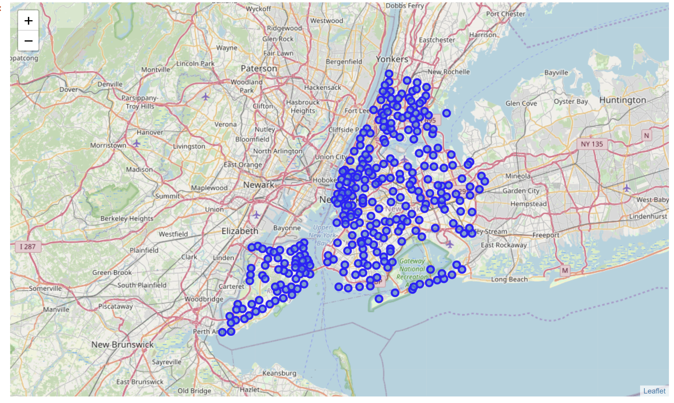

Figure 1. Map of New York with each district marked in blue.

We decide to focus only on the neighboring area of Manhattan for our analysis, which are reported in Figure 2.

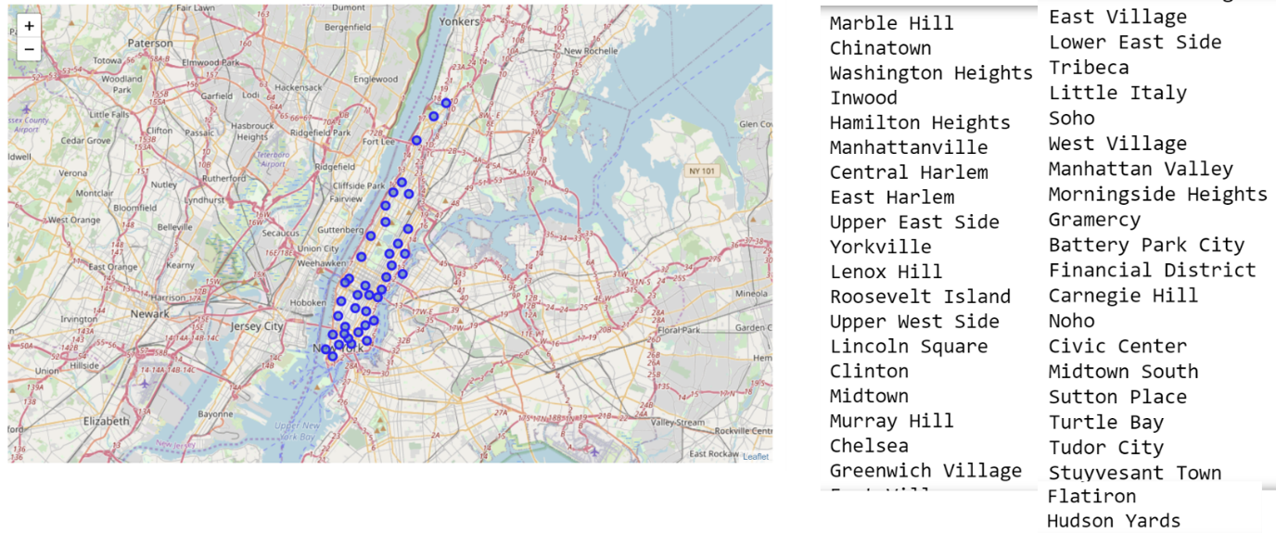

Figure 2. Zoom of the Manhattan area with its neighbourhoods marked in blue and listed on the right hand side.

**3.2 Venue information**

We collect venues information about the Manhattan neighborhoods using Foursquare.

First we drop several venues that we consider not necessary for our analysis such as categories which do not include keywords like ‘Bar’ or “Restaurant”. For each neighborhoods we define the 5 most visited venues as important information to check the Wine Bar popularity (Figure 3).

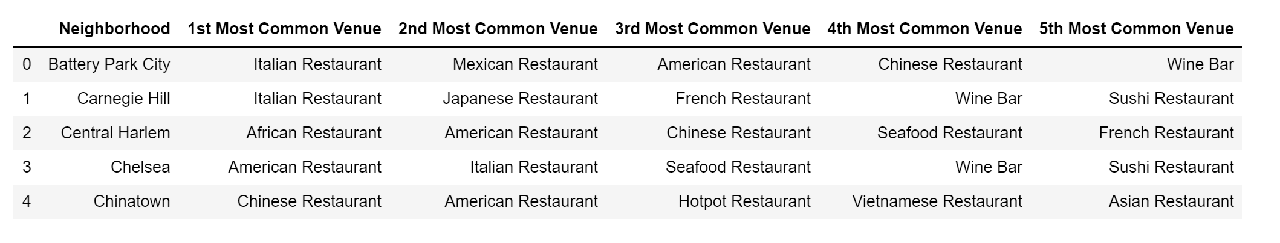Figure 3. Dataframe containing the 5 most visited venues for each Manhattan neighborhood.

**3.3 Clustering**

Then we perform a clustering of the venues based on attributes only relative to Bar and Restaurants. We decide to classify the neighborhoods into 5 clusters, and the results are reported in Figure 4.

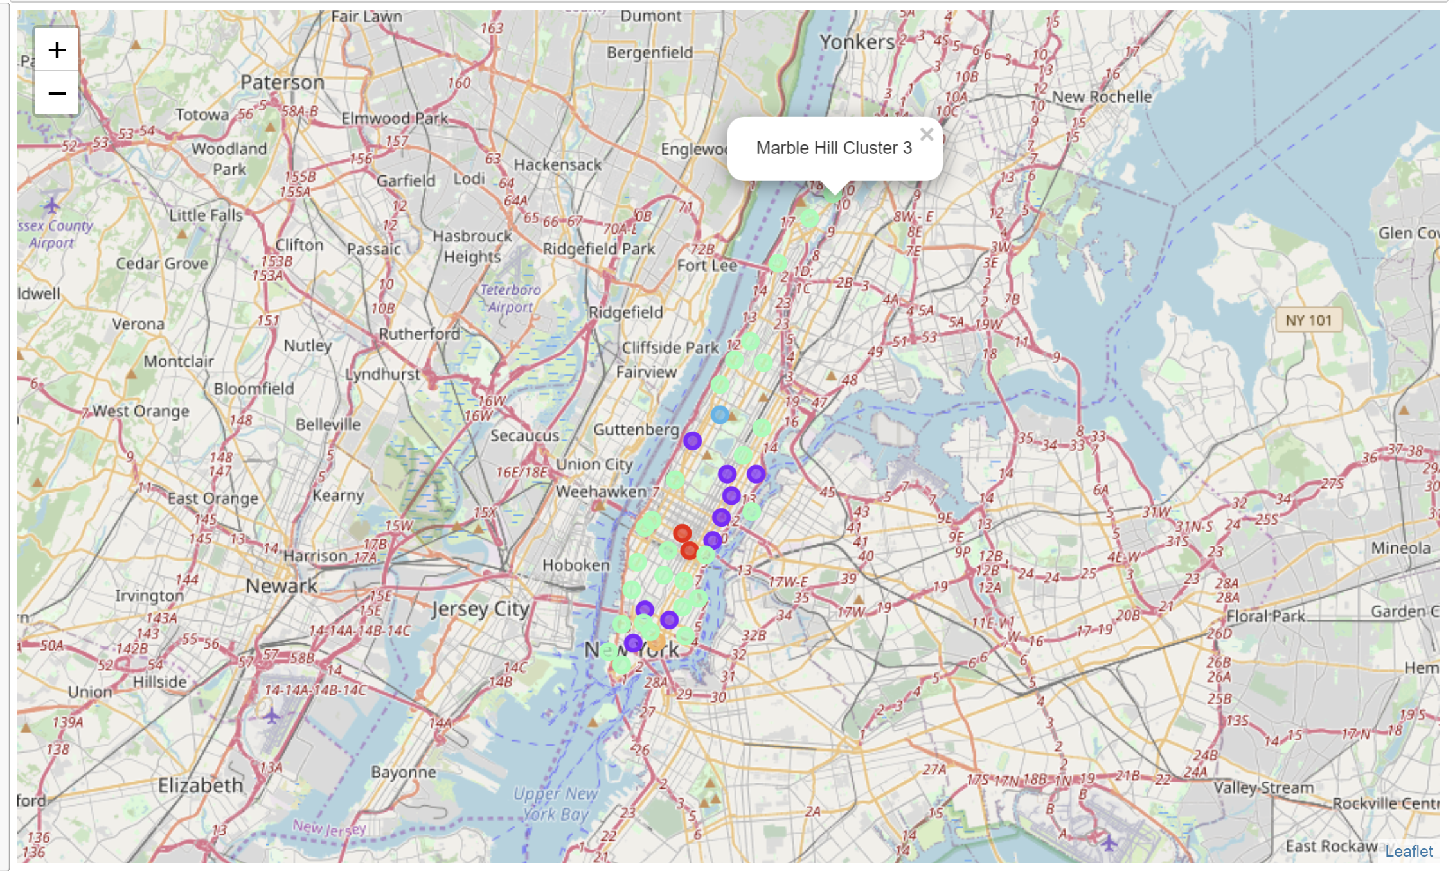

Figure 4. Map of Manhattan neighborhoods divided into 5 clusters based on Bars and Restaurants visit information.

Thus, we can build the dataframe reported in Figure 5, containing information on each neighborhood (name, latitude, longitude), cluster label and the 5 most visited venues.

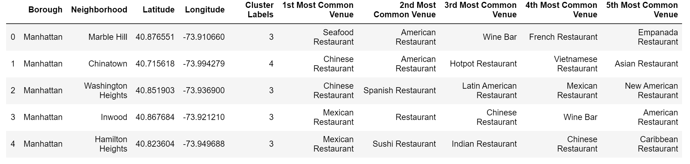  
Figure 5. Dataframe containing information on each neighborhood (name, latitude, longitude), cluster label and the 5 most visited venues.

**3.4 Most visited venues**

We can analyse the occurrence of each category of restaurants and bars in the 1st – 5th Most Common Venue , as reported in Figure 6.

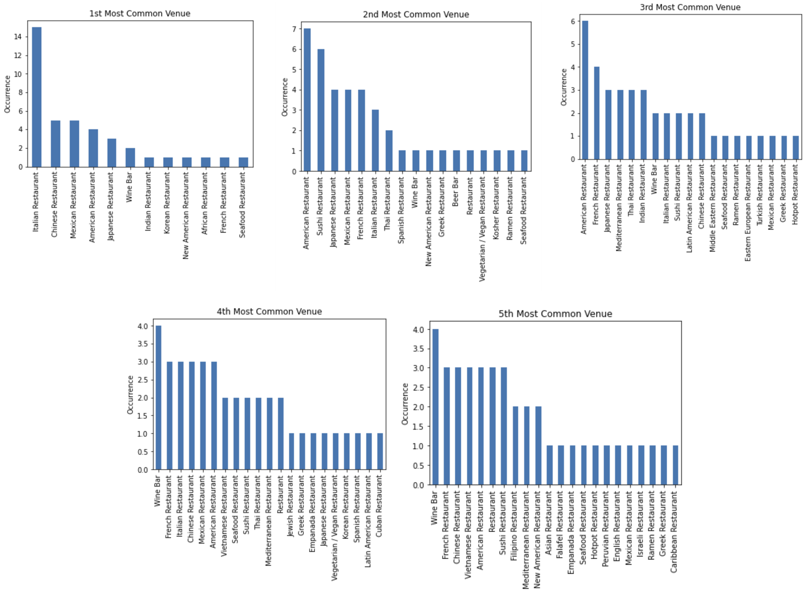  
Figure 6. Occurrence of each bar and restaurant category as 1st – 5th Most common Venue.

We can see from Figure 6 top-left panel, that Wine Bar appears twice as 1st Most visited Venue. Then we find the neighborhoods where this happens, they are reported in Figure 7.

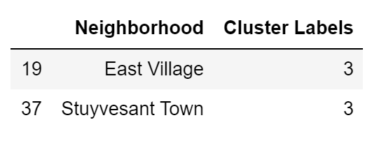  
Figure 7. Name of neighborhood and cluster label of the area around Manhattan with ‘Wine Bar’ as 1st most visited venue.

As reported in Figure 7, the best neighborhoods to open a successful Wine Bar are East Village and Stuyvesant Town, both belonging to Cluster number 3.

**4. Conclusions**

The aim of this project is to find the best neighborhood around Manhattan to open a new Wine Bar as investment.

We analysed the neighborhoods of Manhattan and we listed the venues in each area.

We clustered the areas in 5, and we found the best area to open a Wine Bar based on similar features in that area, they are East Village and Stuyvesant Town, both belonging to Cluster number 3.